Term Work 05

Name : SACHI BHAT

USN: 2GI20CS114

Date: 12-07-2022

Faculty: Dr. Manjula R

OUTPUT:

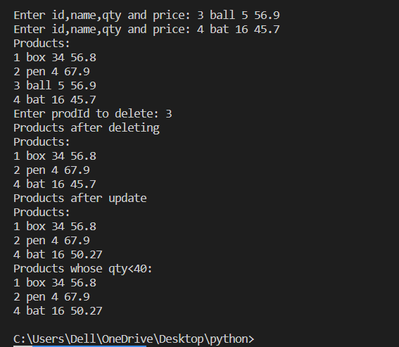

Term Work 05

Name : SHIVANI BANKE

USN: 2GI20CS140

Date: 12-07-2022

Faculty: Dr. Manjula R

OUTPUT:



Term Work 05

Name : TANVI PAWAR

USN: 2GI20CS191

Date: 12-07-2022

Faculty: Dr. Manjula R

OUTPUT



Term Work 04

Name : SACHI BHAT

USN: 2GI20CS114

Date: 12-07-2022

Faculty: Dr. Manjula R

OUTPUT:

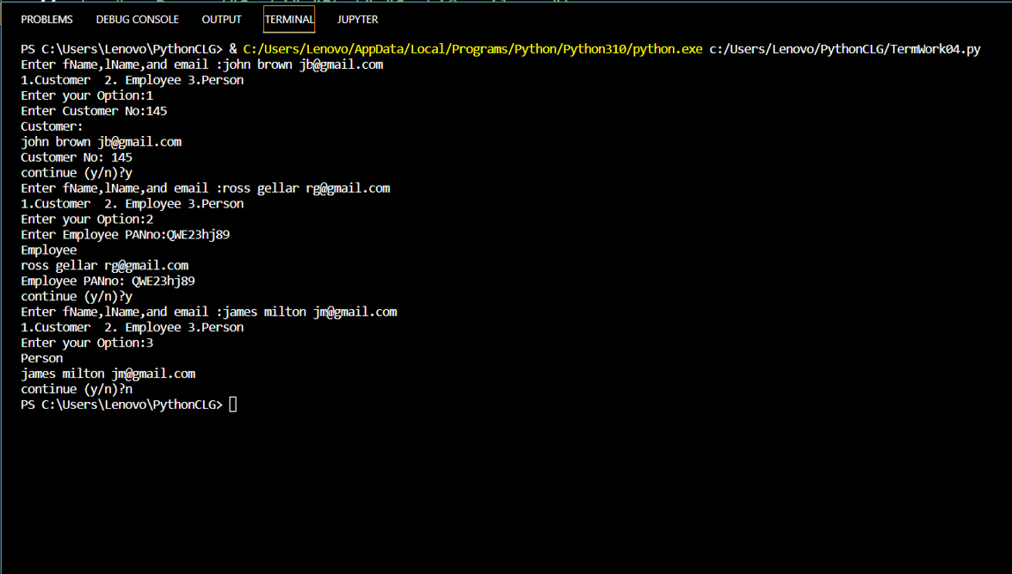

Term Work 04

Name : SHIVANI BANKE

USN: 2GI20CS140

Date: 12-07-2022

Faculty: Dr. Manjula R

OUTPUT:



Term Work 04

Name : TANVI PAWAR

USN: 2GI20CS191

Date: 12-07-2022

Faculty: Dr. Manjula R

OUTPUT:

